

December 11, 2020

The Honorable Gavin Newsom

Governor, State of California

State Capitol

Sacramento, CA 95814

Dear Governor Newsom:

We write today out of great concern for the future of California’s restaurant industry. The COVID-19 guidelines implemented by your Administration have had a devastating impact on the restaurants that provide critical jobs and revenue to our communities. Many restaurants have gone out of business, and now, with the approach of winter and new guidelines that restrict indoor dining, many others will be forced to consider a similar choice.

We ask that you immediately reclassify the restaurant industry as critical infrastructure before even more damage is done to our communities. As is becoming obvious to Californians, these essential businesses do more than simply provide a place to eat. Restaurants are active participants in local neighborhoods, providing meals to senior citizens and working with food banks to feed families struggling to put food on their tables.

The California Restaurant Association reports that 60% of California restaurants are owned by people of color, and 50% of California restaurants are owned or partly-owned by women. In 2019, more than 1.8 million jobs were attributed to the restaurant and food service industry in California. This equates to approximately eleven percent of employment in the state. Closed restaurants means jobs lost, missed rent, mortgage and car payments and a lot of unemployment checks.

California’s restaurants have taken significant steps to ensure the safety of their employees and customers during this pandemic. The industry has proposed guidelines that would allow restaurants to continue to operate safely and at capacity levels that will allow restaurants to stay afloat, while at the same time implementing safety protocols that address the unique challenges inherent with indoor restaurant operations.

We urge you in the strongest terms to reclassify restaurants as essential businesses, and adopt the industry’s protocols that would allow restaurants to operate safely. The future of thousands of restaurants, their employees and the unique character of our local communities are dependent on the survival of this industry. Thank you for your urgent consideration of this request.

Sincerely,

******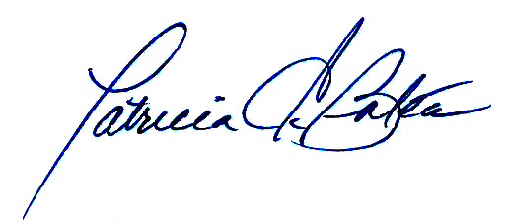

___________________________________ ___________________________________

Patricia C. Bates Shannon Grove, 16th Senate District

Senator, 36th District Senate Republican Leader

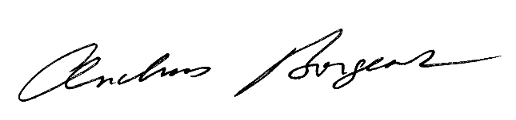

___________________________________ ___________________________________

Andreas Borgeas Brian Dahle

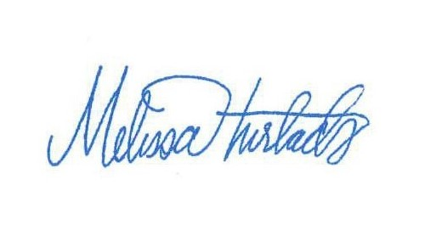Senator, 8th District Senator, 1st District 

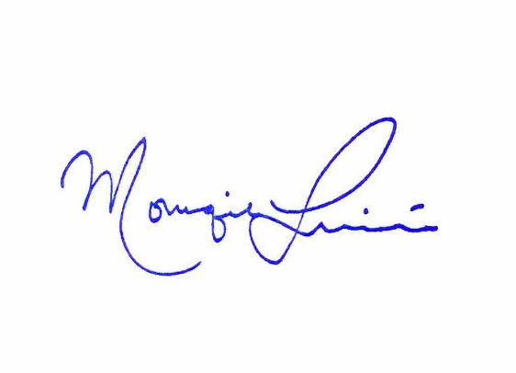___________________________________ ___________________________________

Melissa Hurtado Brian Jones

Senator, 14th District Senator, 38th District

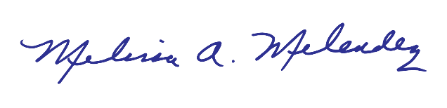

___________________________________ ___________________________________

Monique Limón Melissa Melendez

Senator, 19th District Senator, 28th District

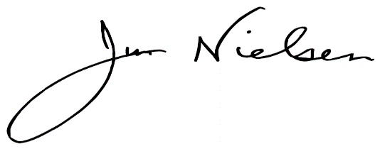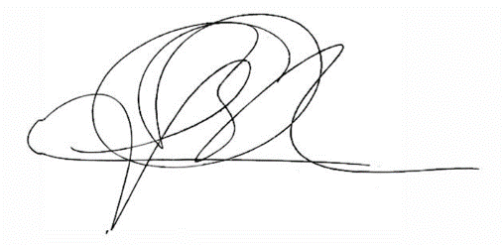

___________________________________ ___________________________________

Jim Nielsen Rosilicie Ochoa Bogh

Senator, 4th District Senator, 23rd District

cid:image001.png@01D6CF07.1D2764D0

___________________________________

Scott Wilk

Senator, 21st District